 **UNIVERSIDAD AUTONOMA DE COAHUILA**

**CENTRO DE IDIOMAS U.S**

**REMEDIAL EXAM**

**LINK IT 1B**

**LEVEL 2**

**STUDENT’S NAME: ____________________________________ DATE: ________________**

**TEACHER’S NAME: ____________________________________**

**PART I. VOCABULARY (15 points)**

Look at the pictures. Complete the labels.

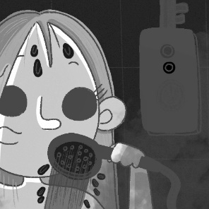 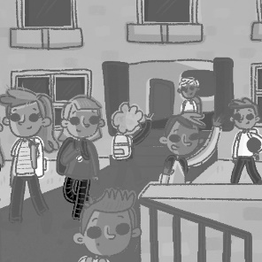

**1** t _ _ e a s _ _ w_ r **2** f _ _ _ _ h sc _ _ _ l **5** _ _ v _ br _ _ _ fa _ t

**3** h _ _ e l _ _ _ h **4** g _ t h _ _ e **6** w _ _ _ h T

Complete the lists with the words in the box.

|  |
| --- |
| salmon corn soda cheese peaches ham |

**1** DRINKS: milk, orange juice, __________

**2** FISH: tuna, __________

**3** DAIRY PRODUCTS: milk, __________

**4** VEGETABLES: carrots, peas, __________

**5** FRUIT: grapes, pears, __________

**6** MEAT: chicken, __________

Complete the sentences with adverbs made from the adjectives in parentheses.

**1** Max works ______________ every day. (hard)

**2** Emma swims very ______________. (slow)

**3** My friends sometimes arrive _____________. (early)

**PART II. GRAMMAR (15 points)**

Complete the sentences with the correct form of the verbs in parentheses.

**1** I __________ (make) pizza every weekend.

**2** He __________ (sing) at school.

**3** My parents often __________ (listen) to music.

**4** My grandpa __________ (speak) French and Japanese.

**5** Ella __________ (play) the guitar.

Complete the sentences with object pronouns.

**1** Mrs. Jones is our teacher. She teaches ____ French.

**2** This music is terrible. I hate ____!

**3** That’s my ice cream! Give it to ____!

**4** My grandma is awesome. I love ____.

**5** Your friends are cool. I like ____.

Complete the present progressive sentences with the correct form of the verbs in parentheses.

**1** My sister is __________ (talk) to her friend.

**2** The students are __________ (do) a test.

**3** Grandma is __________ (sit) in an armchair.

**4** We are __________ (have) a sandwich.

**5** The children are __________ (swim).

**PART III. LISTENING (5 points)**

T03 Listen to the radio interview. Choose the correct alternatives.

**1** The interviewer is talking to a **famous person** / **student**.

**2** Marcus **never** / **sometimes** walks to school.

**3** He usually has **pizza** / **sandwiches** for lunch.

**4** He visits his **cousins** / **friends** on the weekend.

**5** He rarely **reads** / **watches TV**.

**PART IV. READING (5 points) points)COMPREHENSION**

Read the blog. Then do the exercises.

**Food in Texas**

*How often do you eat in restaurants? What dishes do you love? Do you know how to cook them? This week’s food blog is by Clara West from Corpus Christi, Texas.*

Corpus Christi is a great place to try Texan food—especially fish dishes—because it’s next to the ocean. There are some great restaurants, but my favorite restaurant is my grandparents’ restaurant, The Catch. I often go there after school, and my grandpa teaches me how to cook regional dishes.

Tacos with meat are popular in Texas, but here in Corpus Christi we love fish tacos. Tourists love them, too. They’re white fish in corn tortillas with yogurt, vegetables, Mexican cheese, and special flavorings. Perfect! My favorite dish is Shrimp Picayune. It’s shrimp with lemon juice and brown sugar. It’s fantastic with rice and salad. I have it once a week.

Of course, Texans love meat. Chicken Fried Steak is a famous Texan dish. But it doesn’t have any chicken in it! It’s beef (red meat) fried in egg and flour. People usually eat it with potatoes and vegetables.

On the weekend, my friends and I often have lunch in town. We don’t usually sit in restaurants. We buy sandwiches, pizzas, or tacos. My favorite lunch is a hamburger and fries from a great restaurant called Lulu’s. We sometimes have a float. It’s soda with ice cream in it.

Sundays are great. My parents and I never get up early on Sundays. We sometimes walk to the Yellow Bird Restaurant for a late breakfast. They make a big English breakfast, and we love it! In summer, we have a barbecue by the ocean about once a month. Dad cooks and we sit by the ocean, eat awesome food, and chill out!

Answer the questions.

**1** What is “The Catch”?

______________________________________

**2** When does Clara go to The Catch?

______________________________________

**3** How often does Clara eat Shrimp Picayune?

______________________________________

**4** What do people eat with chicken fried steak?

______________________________________

**5** When do Clara and her family go to the Yellow Bird Restaurant?

______________________________________

**PART V. WRITING (10 points)**

Imagine you and your friends in a photo. Write about what the people are wearing. Use the information in the box.

|  |  |
| --- | --- |
| **Me** | blue leggings, white hoodie |
| **Emma** | green shorts, black top |
| **Zoe and Madison** | school uniform: gray pants, purple polo shirt  red sweater: Zoe ✓ Madison 🗶 |

This is a photo of me and my friends. ___________

_________________________________________

_________________________________________

_________________________________________

_________________________________________

_________________________________________

_________________________________________

_________________________________________